

|  |
| --- |
| Experiment No.7 |
| Perform DCL and TCL commands. |
| Date of Performance: |
| Date of Submission: |

**Experiment No.7**

**Aim :-** Write a query to implement Data Control Language(DCL) and Transaction Control Language(TCL) commands

**Objective :-** To learn DCL commands like Grant and Revoke privileges to the user and TCL commands to commit the transactions and recover it using rollback and save points.

**Theory:**

**Data Control Language:**

DCL commands are used to grant and take back authority from any database user.

○ Grant

○ Revoke

a. Grant: It is used to give user access privileges to a database.

Example

1. GRANT SELECT, UPDATE ON MY_TABLE TO SOME_USER,

ANOTHER_USER;

b. Revoke: It is used to take back permissions from the user.

Example

1. REVOKE SELECT, UPDATE ON MY_TABLE FROM USER1, USER2;

**Transaction Control Language**

TCL commands can only use with DML commands like INSERT, DELETE and UPDATE only.

These operations are automatically committed in the database that's why they cannot be used while creating tables or dropping them.

Here are some commands that come under TCL:

○ COMMIT

○ ROLLBACK

○ SAVEPOINT

a. Commit: Commit command is used to save all the transactions to the database.

Syntax:

1. COMMIT;

Example:

1. DELETE FROM CUSTOMERS

2. WHERE AGE = 25;

3. COMMIT;

b. Rollback: Rollback command is used to undo transactions that have not already been saved to the database.

Syntax:

1. ROLLBACK;

Example:

1. DELETE FROM CUSTOMERS

2. WHERE AGE = 25;

3. ROLLBACK;

c. SAVEPOINT: It is used to roll the transaction back to a certain point without rolling back the entire transaction.

Syntax:

2. SAVEPOINT SAVEPOINT_NAME;

**Implementation:**

1.) DCL Commands:

a.)Grant:





b.) Revoke:





2.) TCL Commands:

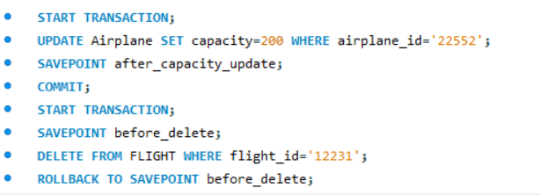

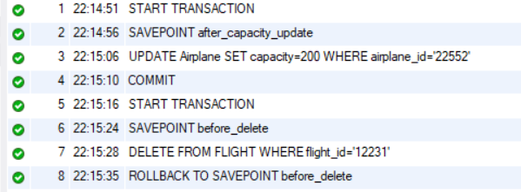

**Conclusion:**

1. Explain about issues faced during rollback in mysql and how it got resolved.

During rollback in MySQL, issues can arise if there are concurrent transactions or if the rollback process encounters errors such as deadlocks. These issues are resolved by ensuring proper transaction management, handling deadlock situations, and using appropriate isolation levels to minimize conflicts between transactions.

1. Explain how to create a user in sql.

To create a user in SQL, you typically use the CREATE USER statement followed by the username and password. Optionally, you can specify additional parameters such as permissions and privileges. For example: CREATE USER 'username'@'hostname' IDENTIFIED BY 'password';